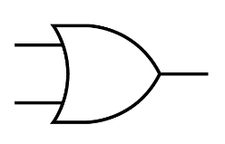**Circuit Diagram & Truth Table:**

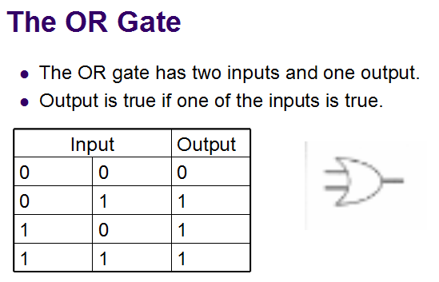

**Code:**

* **Design Module**
* **TestBench**

**Output:**